**NAZIRA COLLEGE, NAZIRA,SIBSAGAR**

**Students Satisfaction Survey (SSS)**

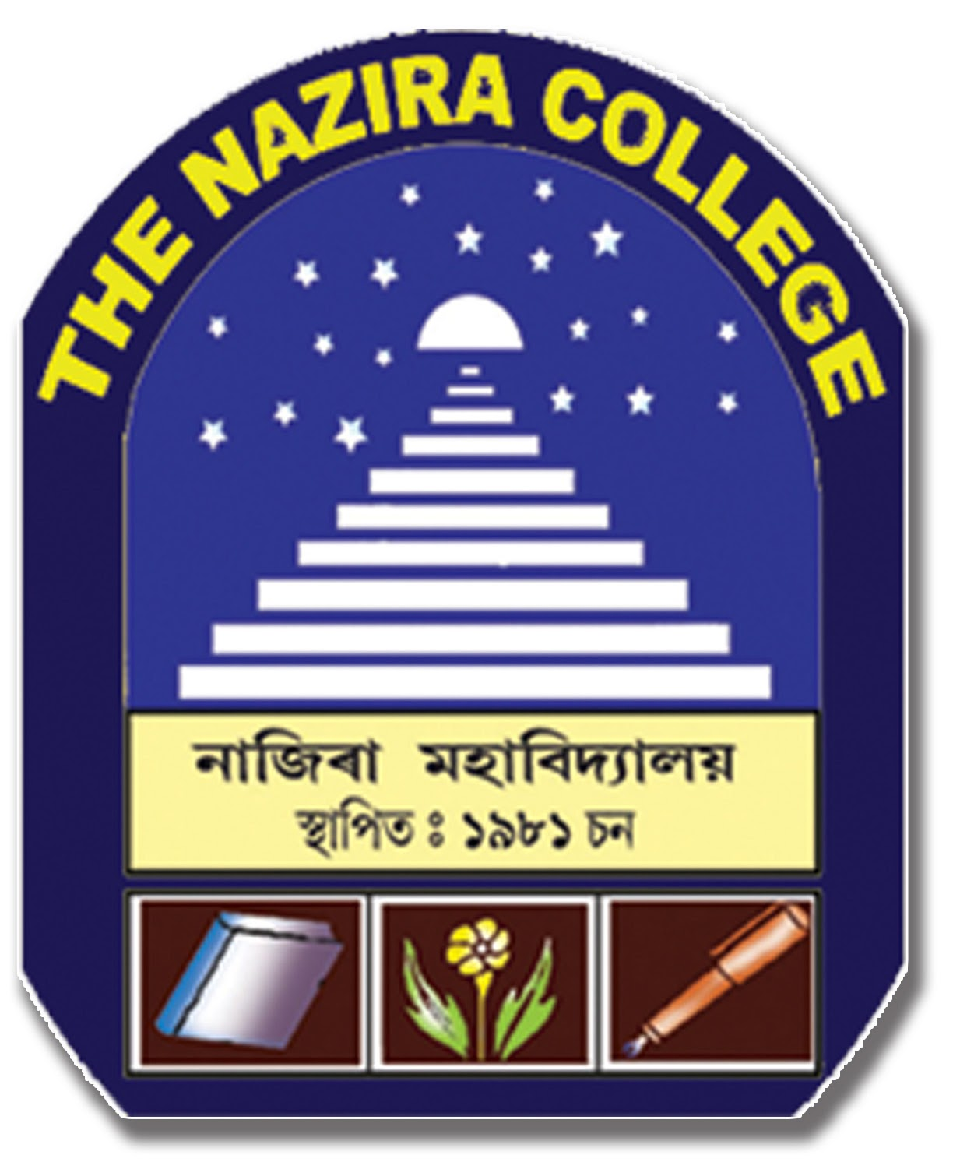



**ACADEMIC YEAR 2023-24**

**NAZIRA COLLEGE NAZIRA**

Students Satisfaction Survey (SSS) regarding Teaching – Learning and Evaluation was conducted among the students of the institute through the website. The questionnaire has been framed based on NAAC guidelines. This removes the binary forced approach and provides a more comfortable wider range for students to register their opinion.

A student will have to respond to all the questions on a Teacher given in the following format with her/his sincere effort and thought. This will help to upgrade the quality in higher education. Her/his identity will not be revealed.

**Teacher’s name: Pubali Hazarika**

**\*\*\*\*\*\*\*\*\*\*\*\*\***

**Teacher Name: ACHYUT HAZARIKA**

***********

**TEACHER NAME: DR. MINAKHI HAZARIKA**

********

**TEACHER’S NAME: DR. PALLAB KONWAR**

***************************&***********************