NAZIRA
COLLEGE
NAGA ALI, NAZIRA, SIVASAGAR, ASSAM, 785685
Affiliated to Dibrugarh University
NAAC Accredited in 2021 (B⁺)

Activity Report on the one day state level workshop on ‘Rain Water Harvesting and Watershed Development’

The Geography Department organized a one day state level workshop on ‘Rain Water Harvesting and Watershed Development’ on 8th April, 2022 in the College premises. Resource persons for the workshop were Rituraj Neog, Asssistant Professor, Department of Geography, Gargaon College, Gargaon along with Juri Borah, Assistant Professor, Department of Geography, D.C.B. Girl’s College.
Both the Resource Person delivered their views on the burning issues like scarcity of clean water , use of rain water, harvesting of rain water and its importance to tackle the problem. Faculty members present in that workshop also offers their views.
Dr. Ajit Ch. Borah, Dept. of Geography, Nazira College welcome all the participants at the beginning and Gajen Sarmah offers Vote of thanks at the end of the workshop..

Photographs

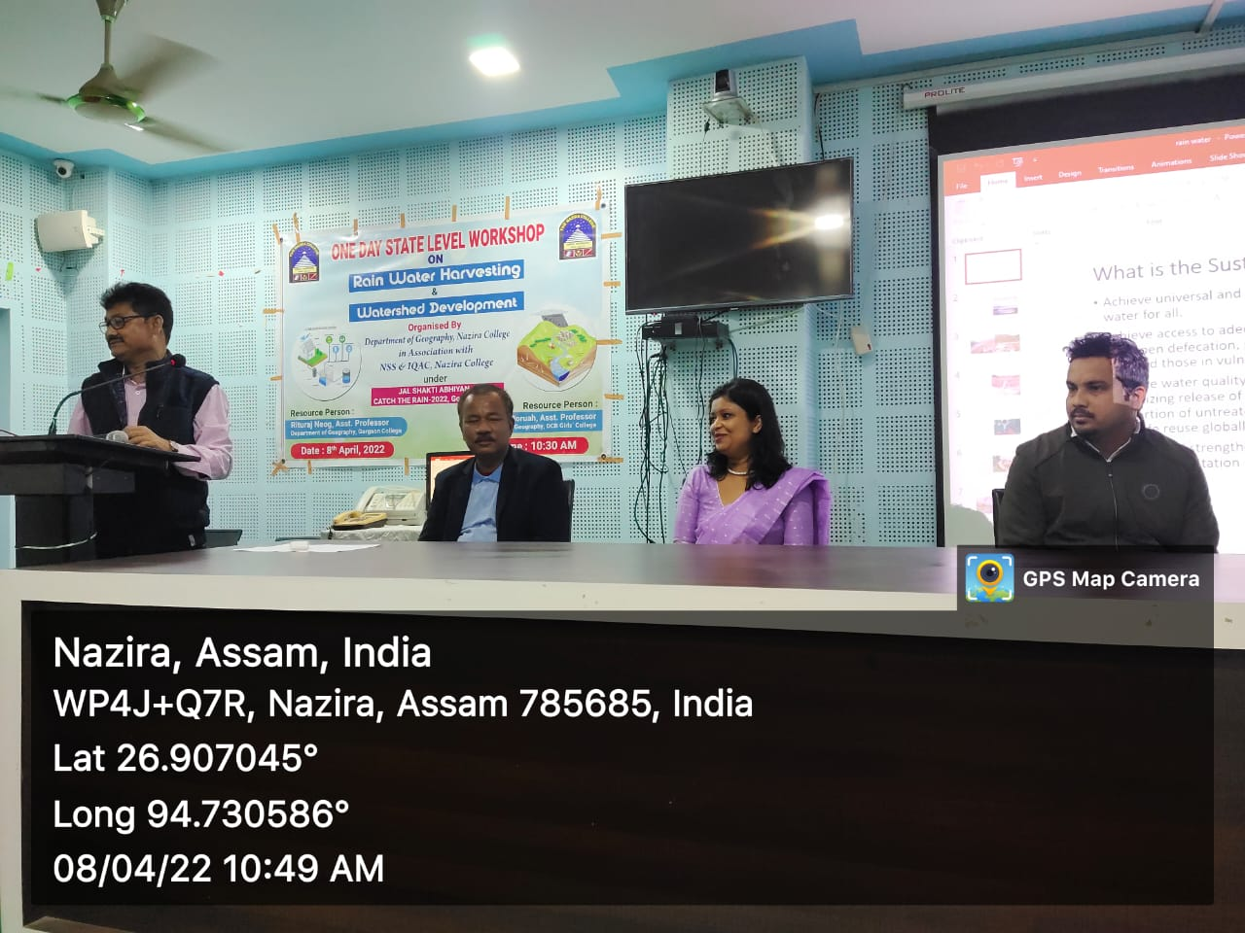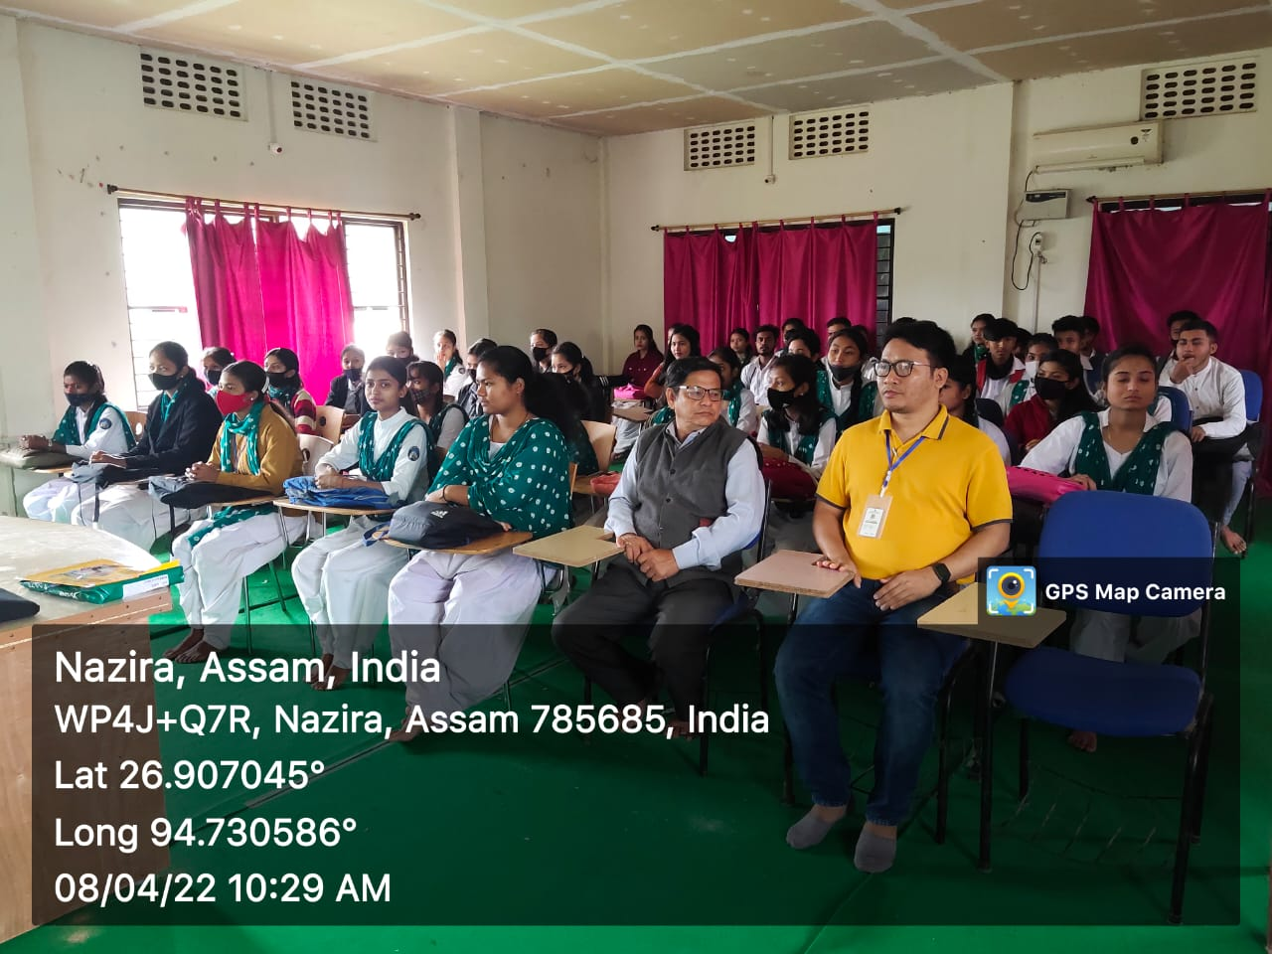

Attendance Sheet



