INVESTOR AWARENESS WEBINAR AT NAZIRA COLLEGE, NAZIRA
Report on the Three days webinar on Investor Awareness Program
A three days webinar on Investor Awareness Program has been convened in the Google Meet Platform organized by the organized by the NSE, Securities and Exchange Board of India in collaboration with Nazira College on 10th , 12th & 18th December, 2020. Almost 40 participants mainly students participated in the webinar. The Resource Persons elaborately discussed about different types of investments available in India particularly in the Stock Market. Participants students were very much benefitted from the webinar and e certificates were awarded to all the participants

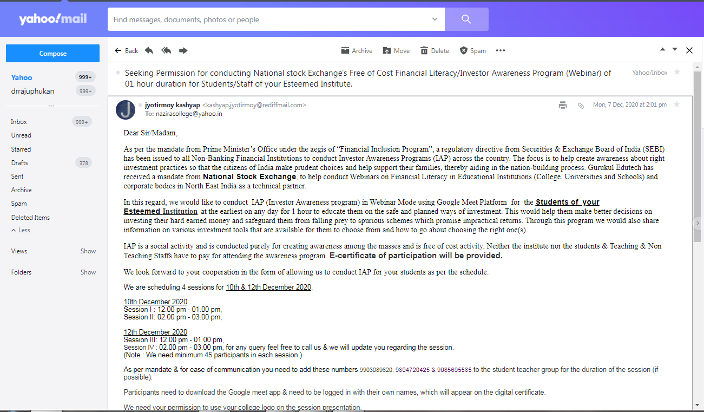
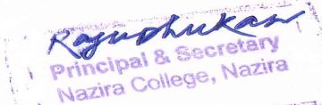
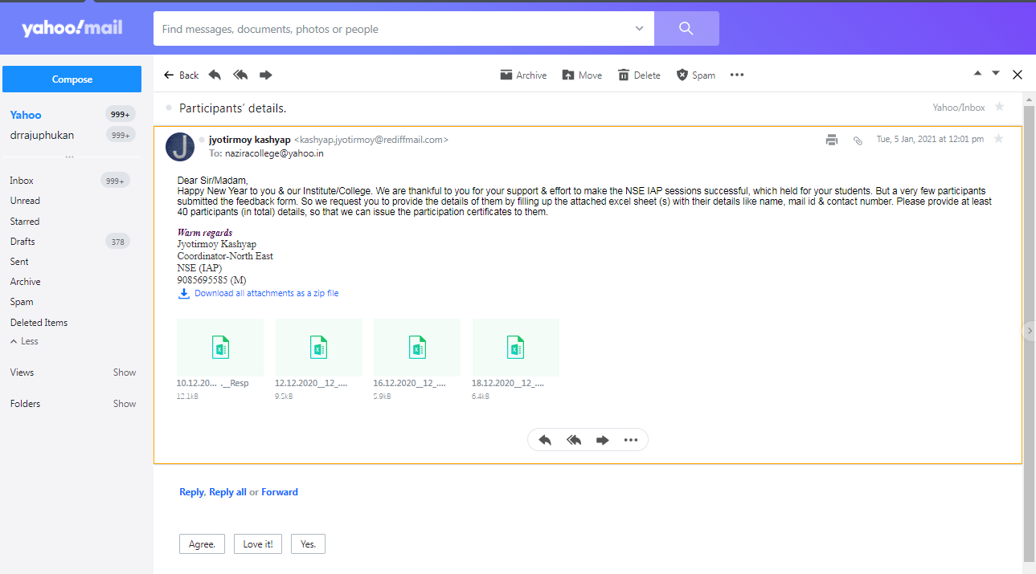
Brochure of three days Webinar on Investor Awareness organized by the NSE, Securities and Exchange Board of India in collaboration with Nazira College.
